**Task1:**

* Create table in Source DB with below fields.
* Generate the data generation rules for each field using TDM available functions.
* Publish the data to Target Database. (Multiple Records)

**Fields for tasks:**

|  |  |  |
| --- | --- | --- |
| **Column Name** | **Datatype** | **Data Definition** |
| CustomerID | int | Numeric and Unique |
| FirstName | varchar | get the data from seed list |
| LastName | varchar | get the data from seed list |
| Dept | Varchar | Get the data from your own defined list |
| Phone | bigint | get the data from seed list |
| Street | Varchar | Create one new seed table with all these 4 fields and select the data from the same table |
| CITY | Varchar |
| STATE | Varchar |
| ZIPCODE | Varchar |

Steps to follow:

1. Create table in Source db in SQL 2012 with above columns and data types (Table is empty)

Table Name: dbo. Details (Travel)

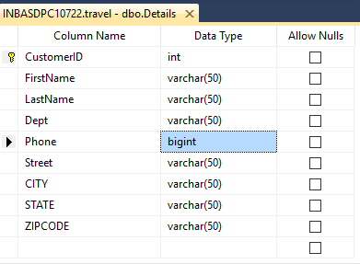

1. Create a table in Target db in SQL 2012 with above columns and data types (Table is empty)

Table Name: dbo. Details (Travel_E)

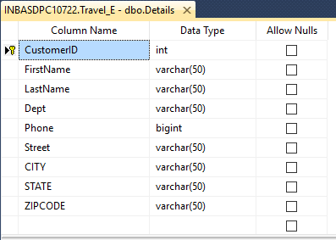

1. Login to Data maker. Create profile accordingly.
2. Create New project and version subsequently, create Data Group, Data set and Data Pool.
3. Goto Projects >Select Register for Registering the table

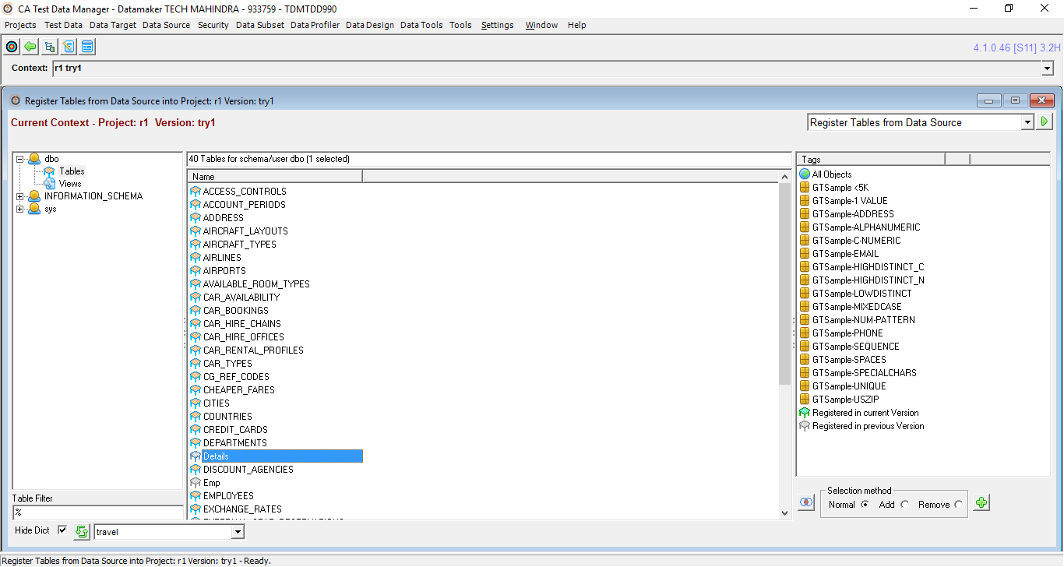

1. Select Projects > Actions for Registered Tables and sample the data for the registered table

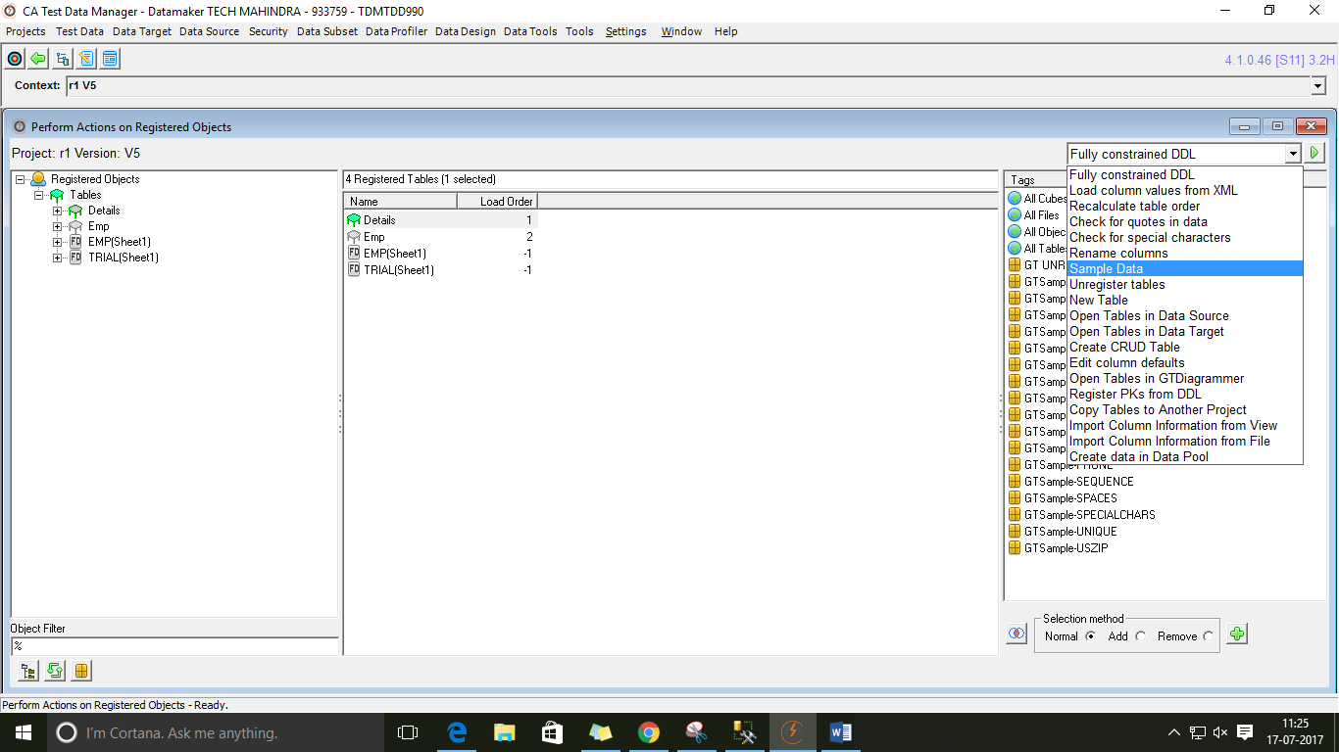

1. Click Ok.

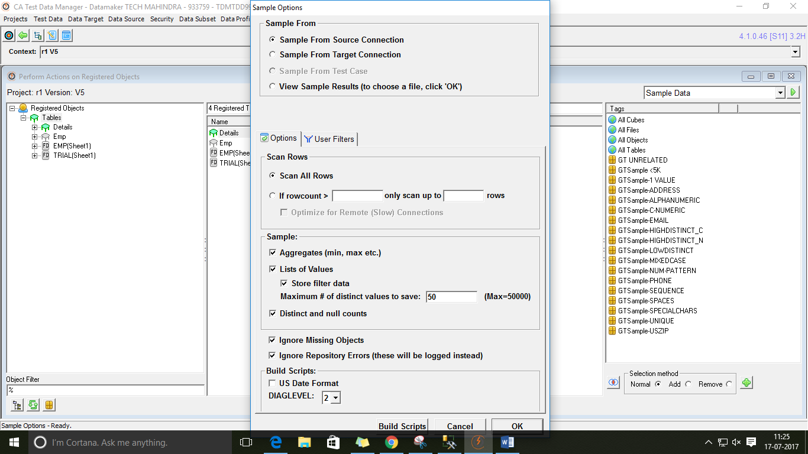

1. Save All.

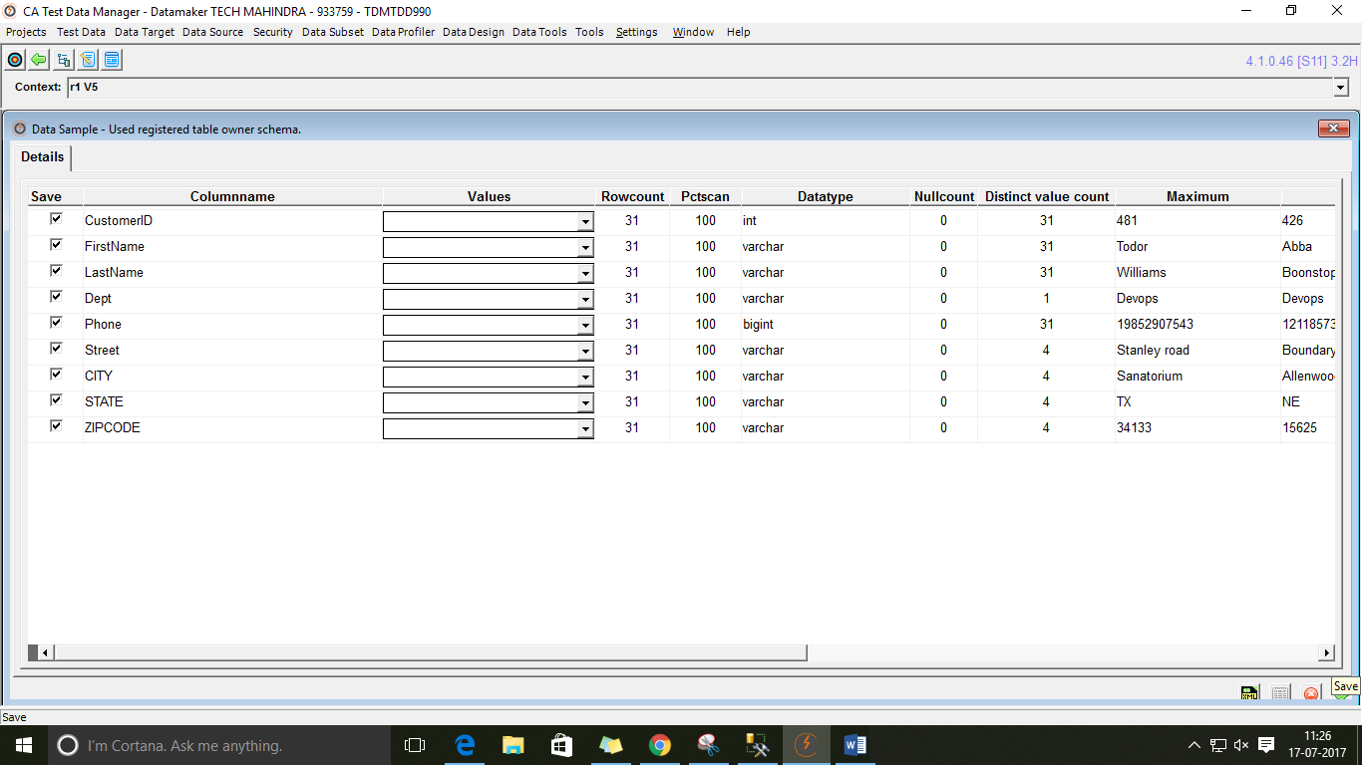

1. Click on run.

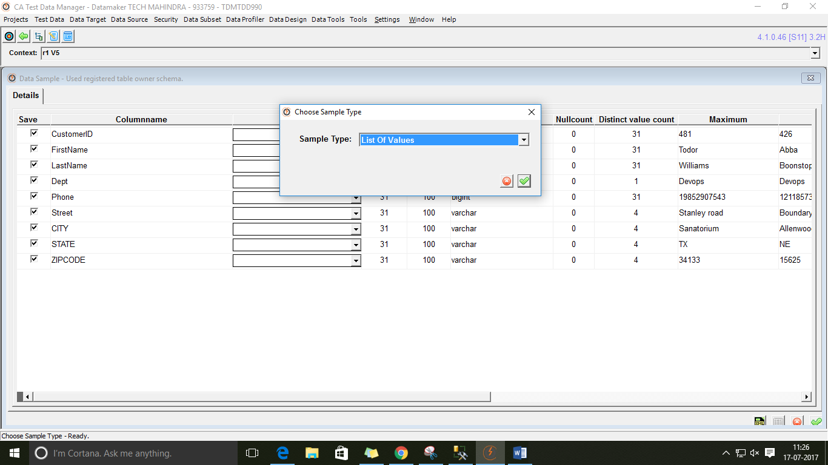

1. Click on run.

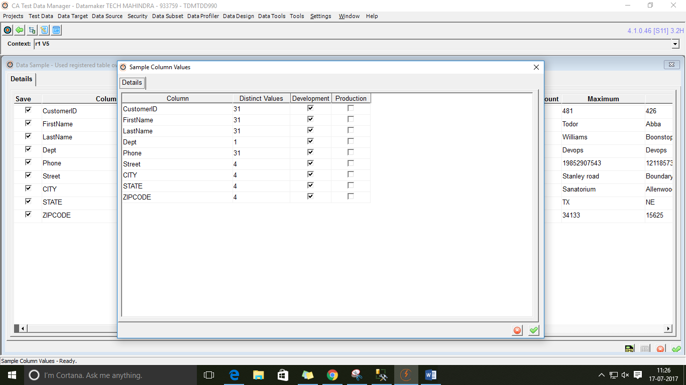

1. Navigate to Home page, refresh and double click the data pool created.
2. Select the table registered (dbo.Details) in Data Definition for Data Pool screen

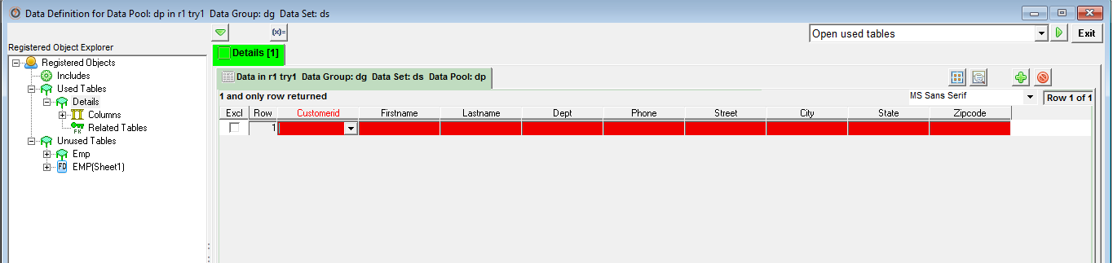

1. Double click the CustomerId column and generate a rule accordingly.

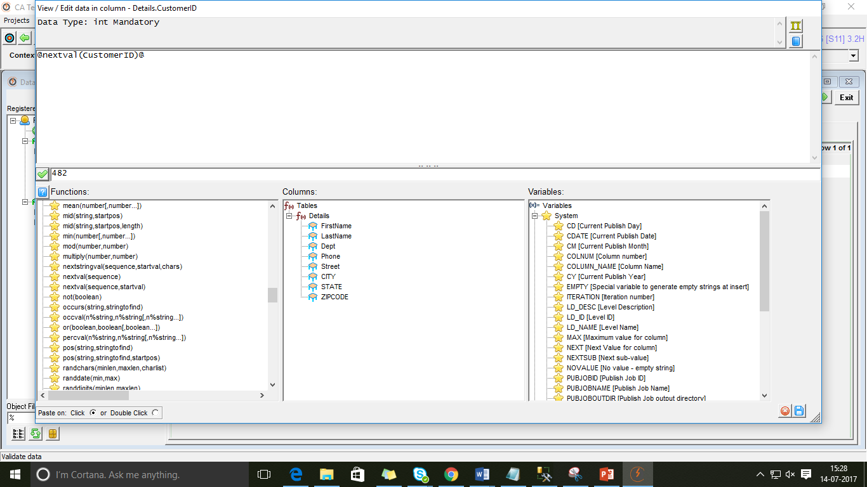

1. Repeat the process for the remaining columns.
2. As per the requirement we need to create a new seed table.

Goto tools>Maintain seed data>Add new seed data type and number of columns (here it is 4)

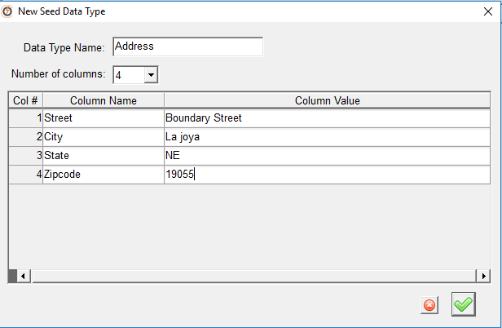

1. Add few row values for the seed table.

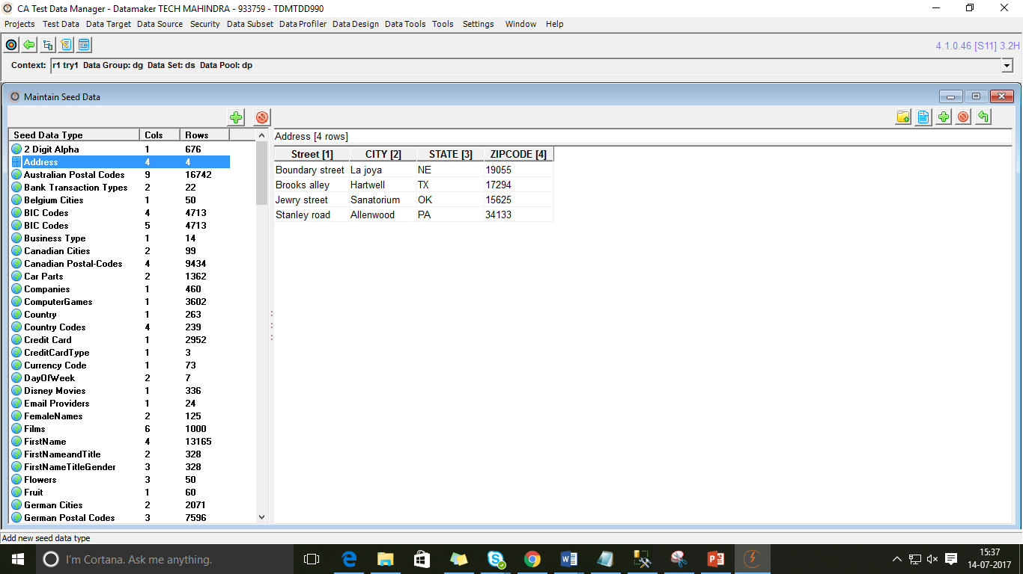

1. Double click Street in Data Definition screen.

Functions > Select **@randlov(percnull,@seedlist(seedname)@,seedcolumn)@**

In Select Required seed list > Address ( Created seed table name)

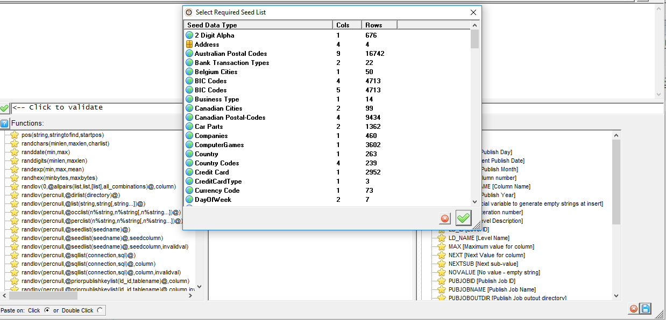

1. Mention below values and validate

Percnull: 0

Seedcolumn:1

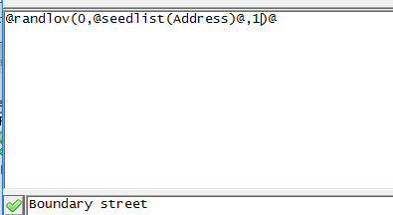

1. Repeat the process as above by changing the seed column values as follows:

City: @randlov(0,@seedlist(Address)@,2)@

State: @randlov(0,@seedlist(Address)@,3)@

Zipcode: @randlov(0,@seedlist(Address)@,4)@

1. Copy same generation rule for ‘n’ rows. Select Publish to data target from drop down.

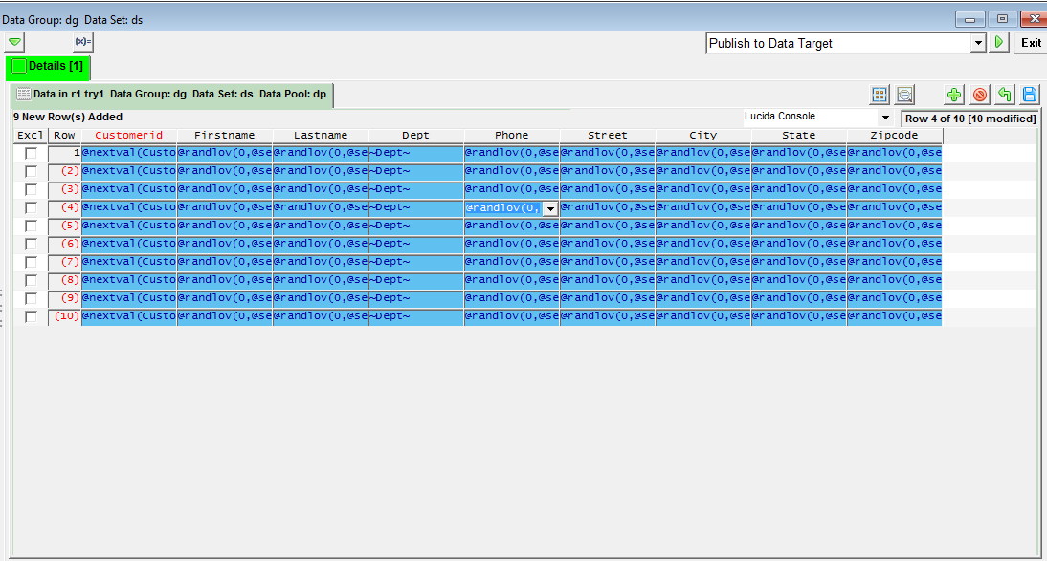

1. Select Publish to data target and run.

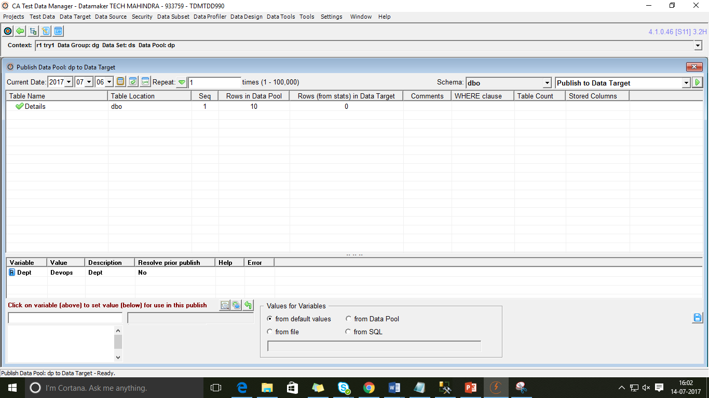

1. Click run

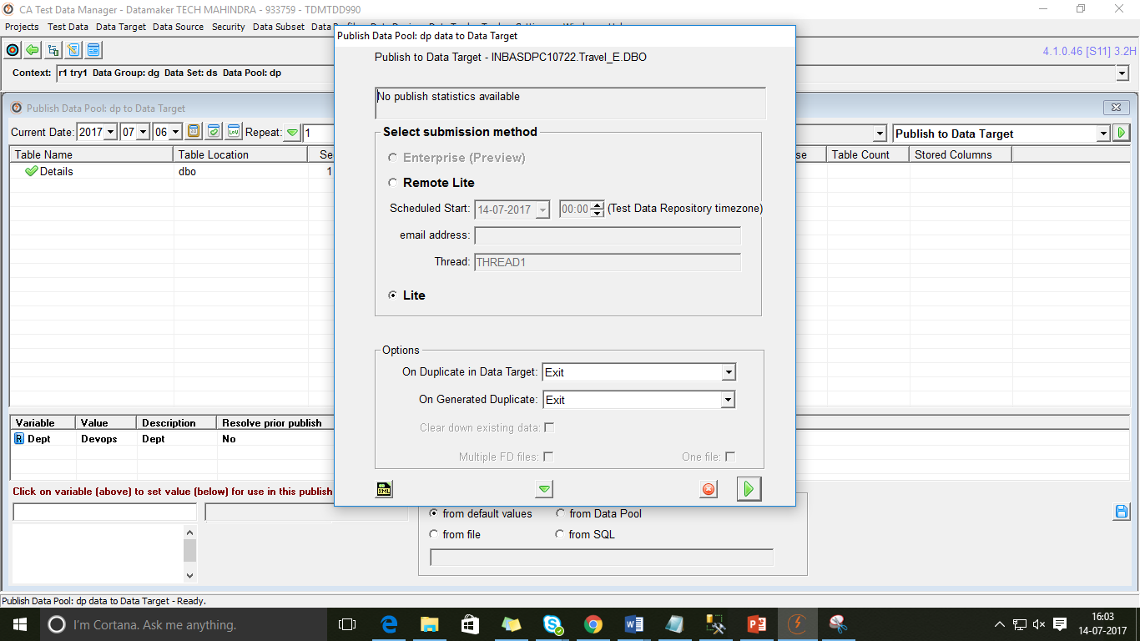

1. Click ok

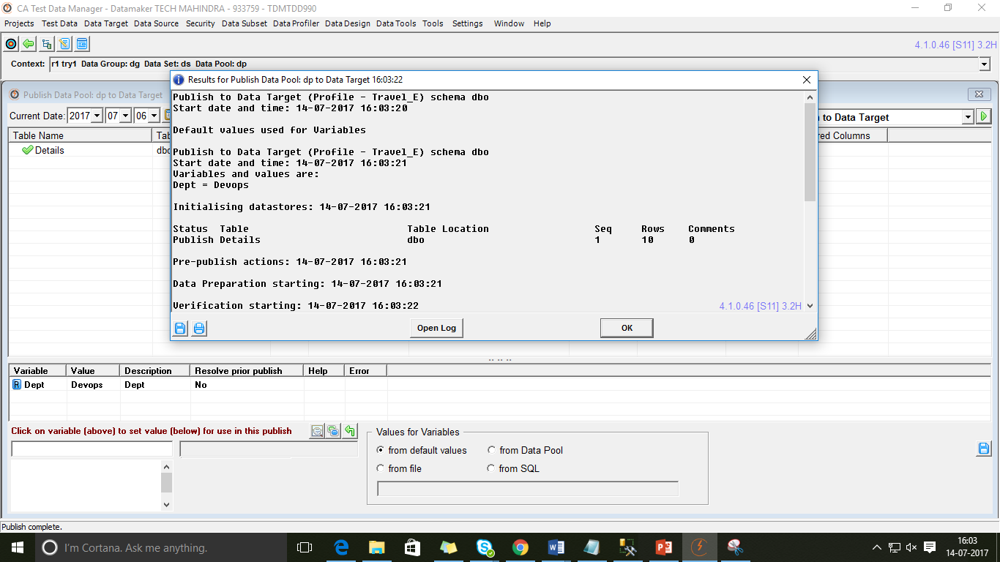

1. Goto Data source and run select query

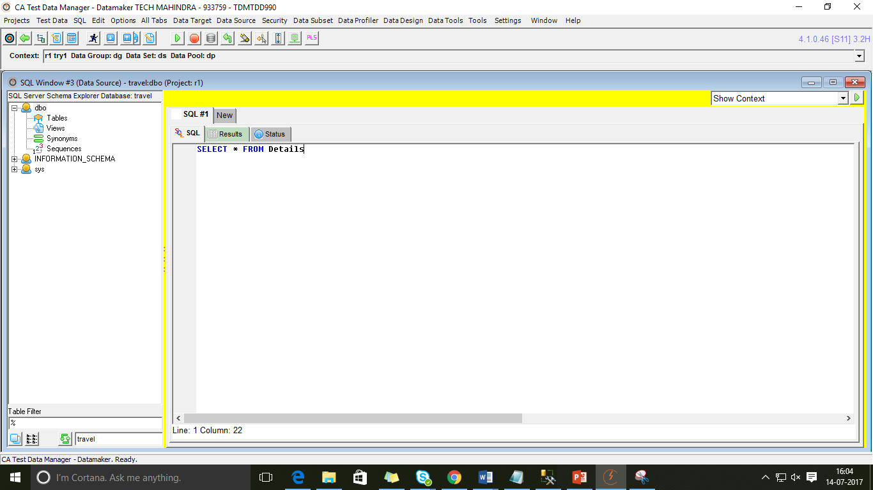

1. Select Change context from drop down

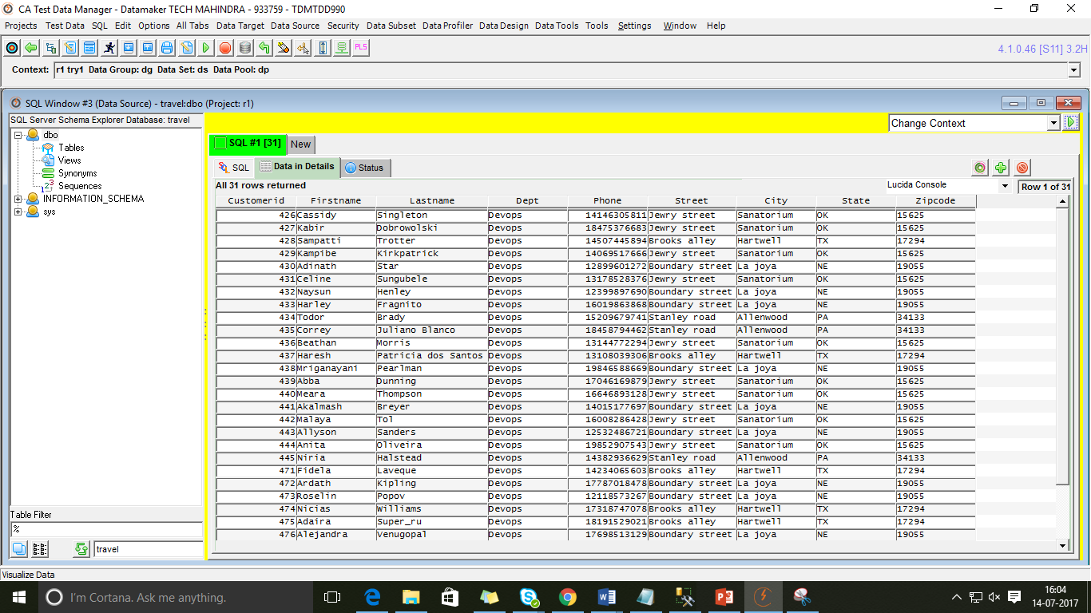

1. Select the created data pool and click run.

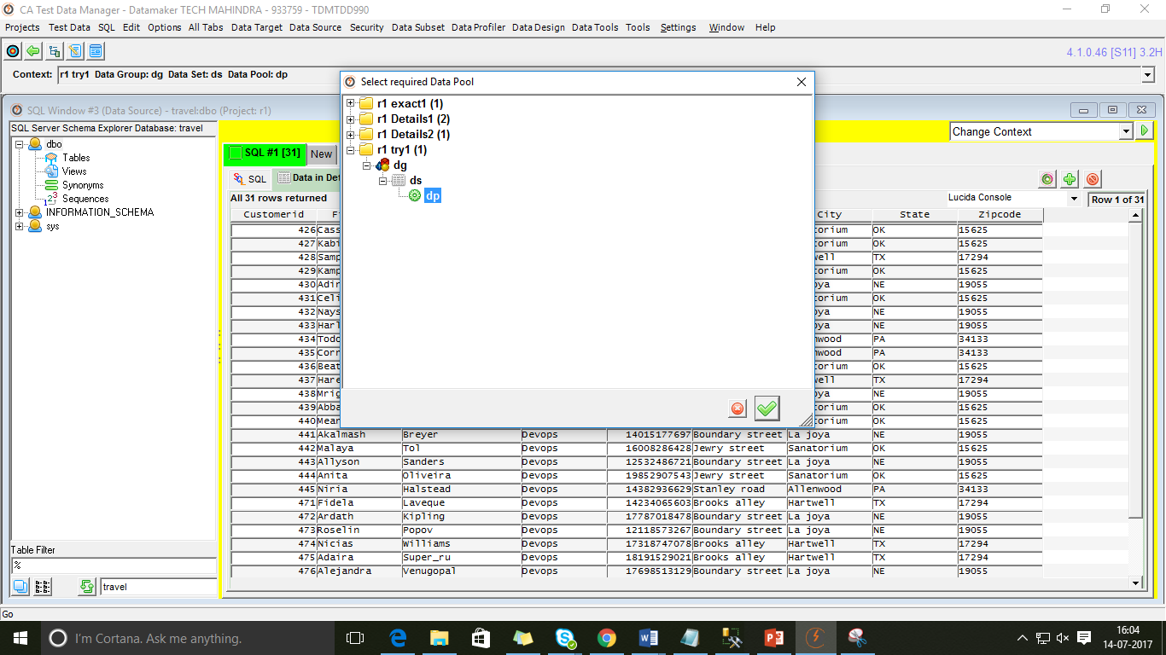

1. Select Write all to data target from drop down and run.

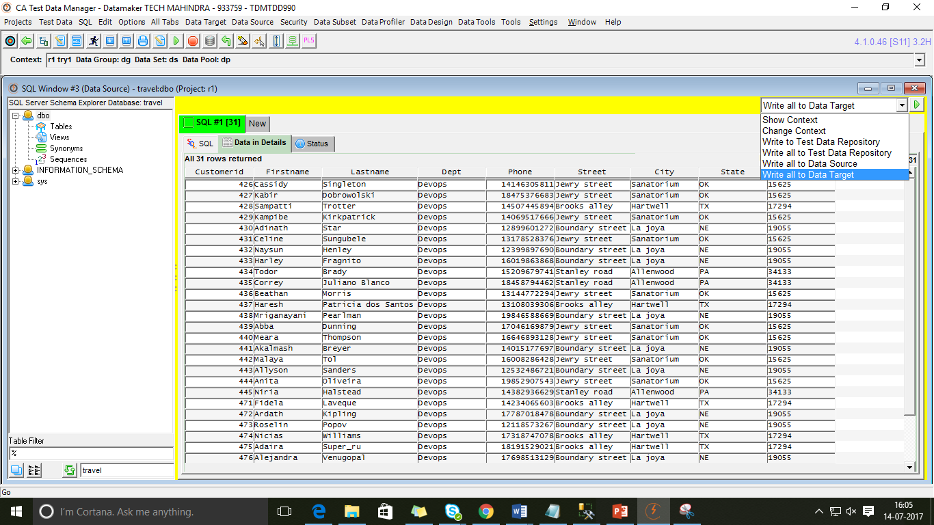

1. Goto data target and run select query.

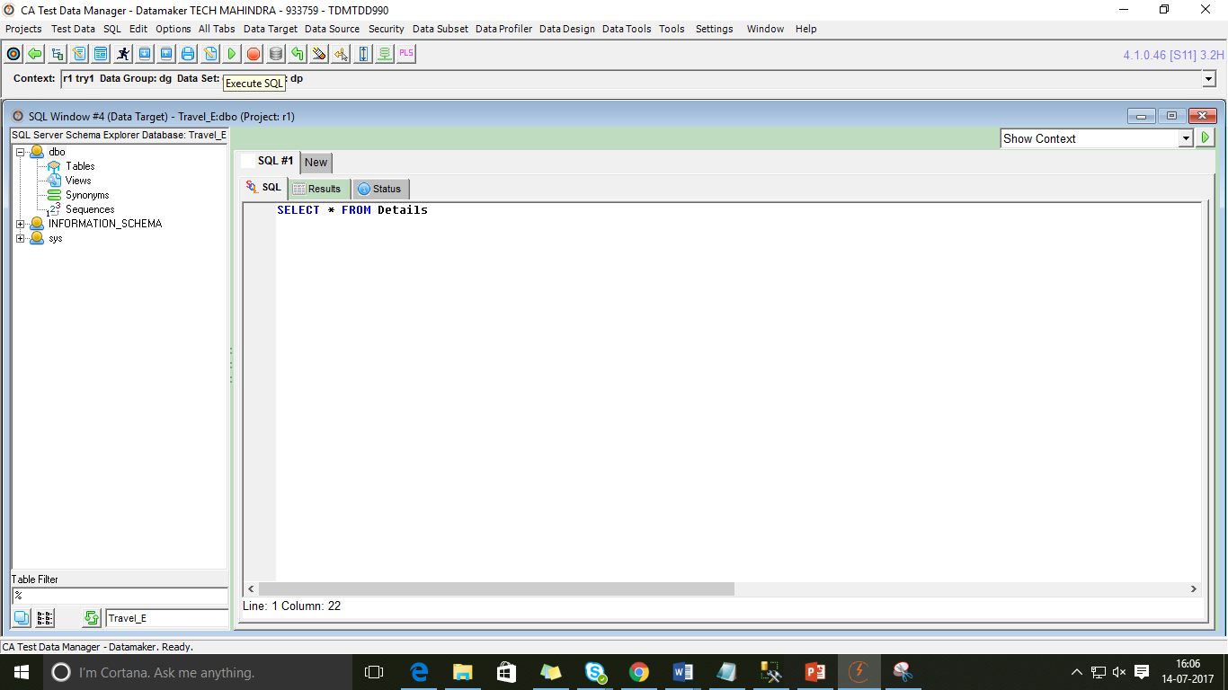

1. Data is published in Target DB.

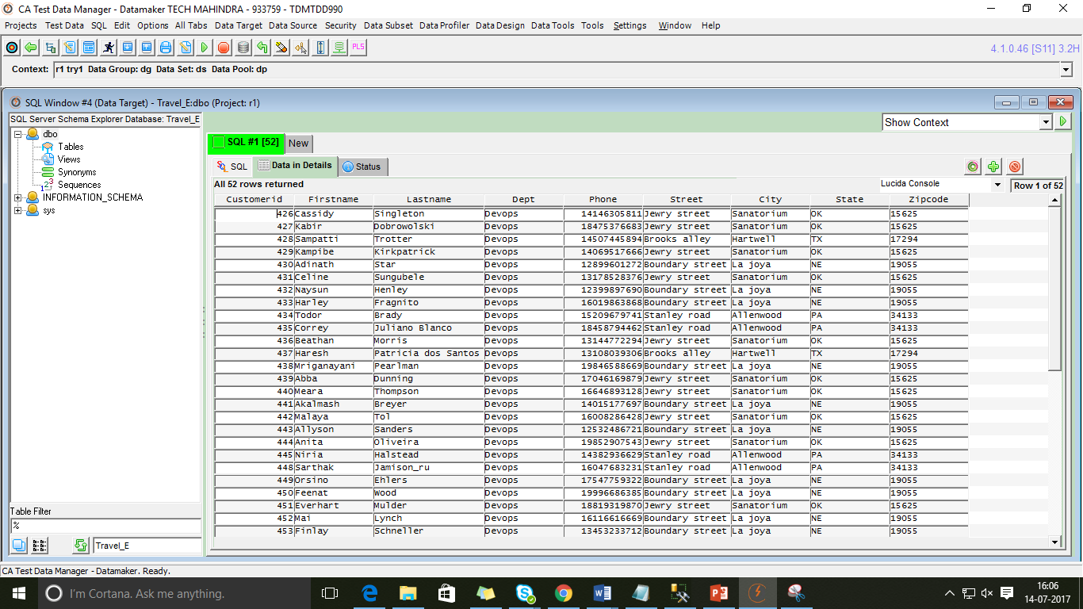

**Task2:**

* Read XL sheet from TDM portal with the below columns.
* Create data generation rules or each field
* Generate multiple records in XL file

Steps to follow:

1. Create a new data pool

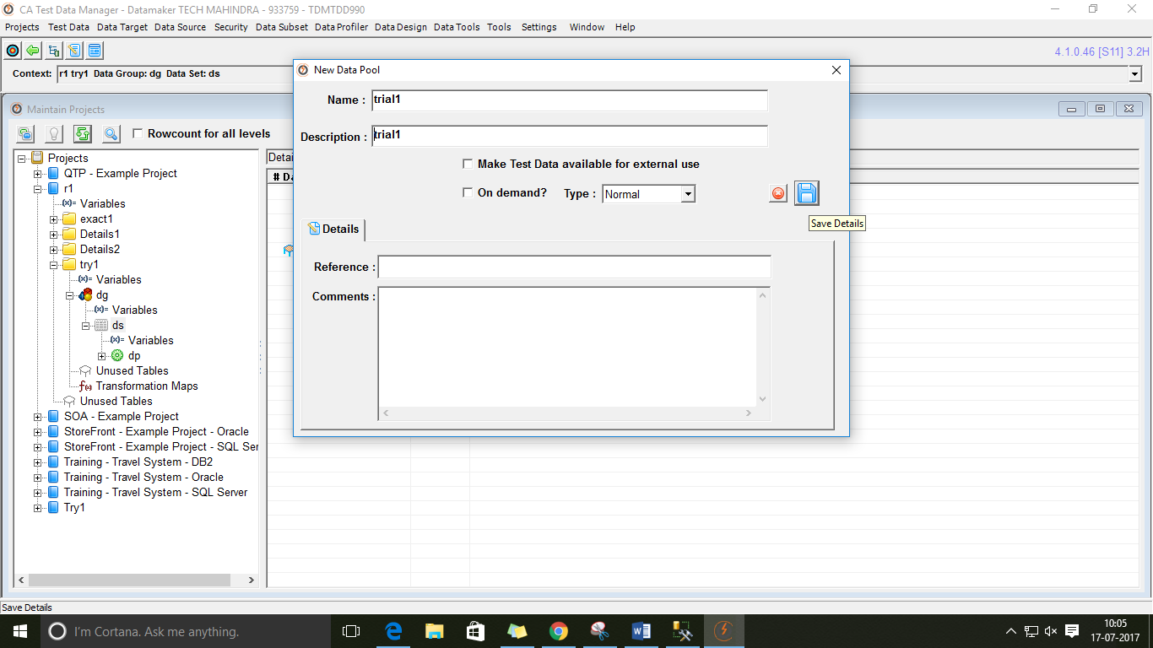

1. Register the excel file.

Goto Projects> Register > Select Excel/CSV file

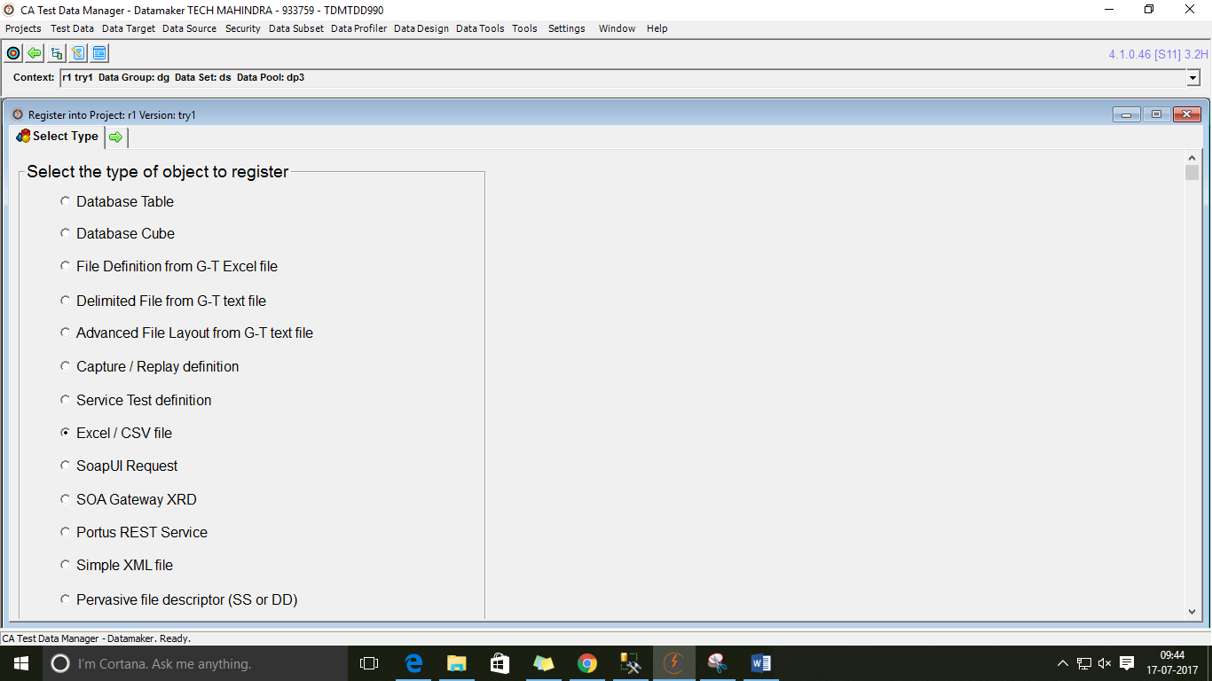

1. Browse the excel file and click on Register/Import

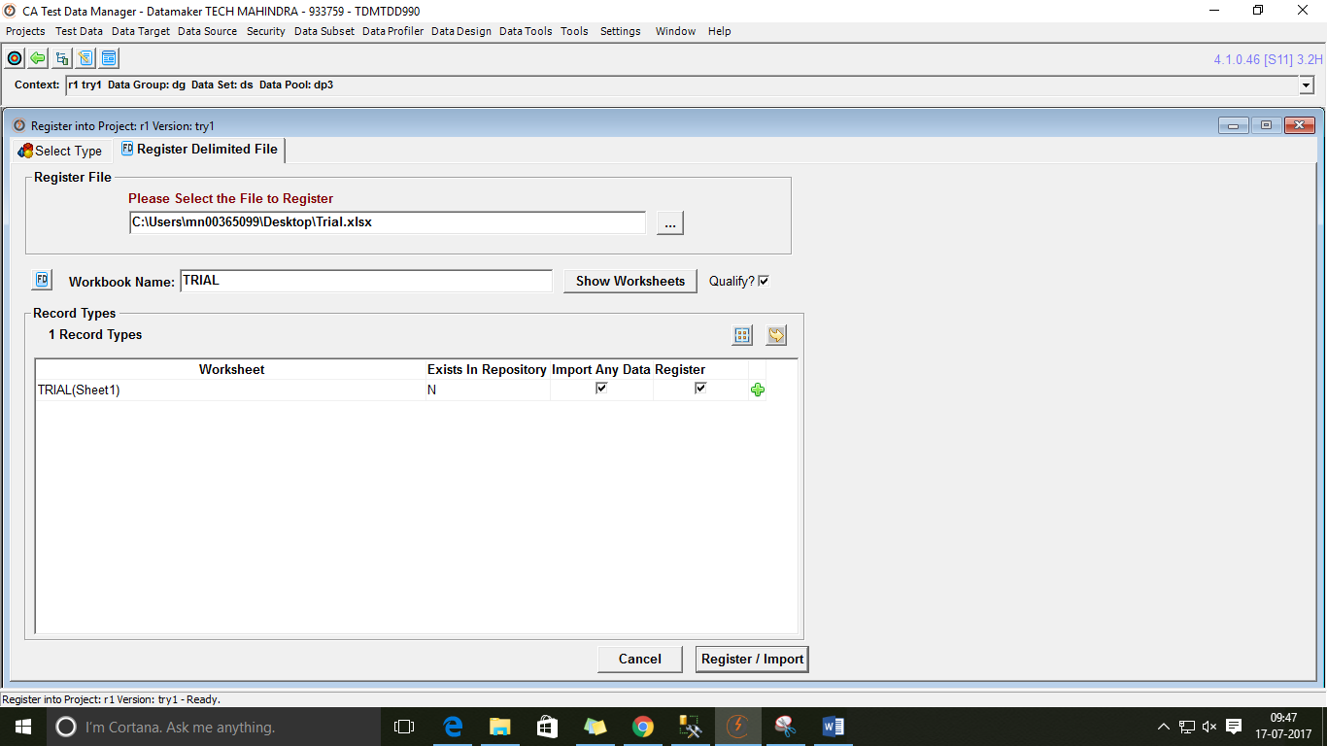

1. Click on OK.

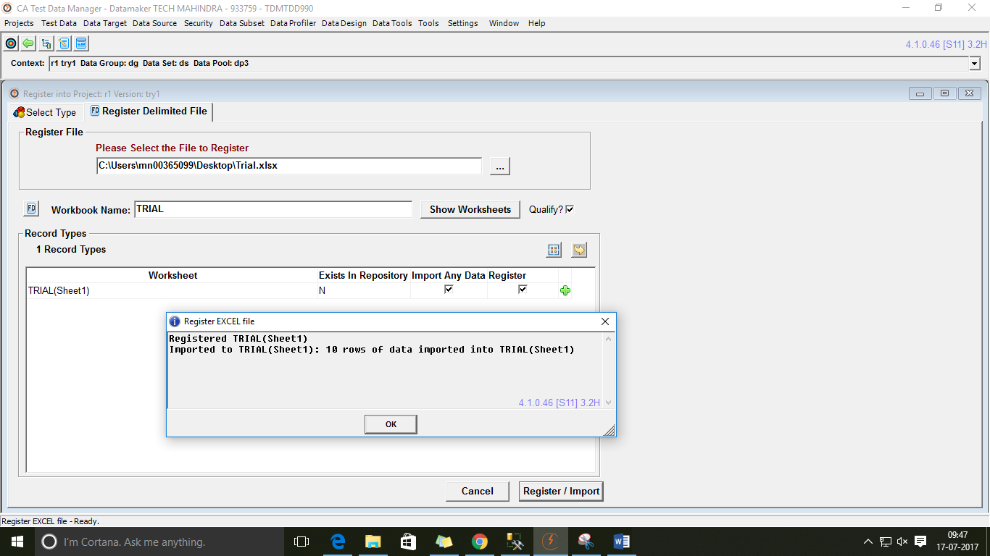

1. Navigate to Home page and refresh and double click the data pool created.
2. Select the excel file registered.
3. Double click Street in Data Definition screen.

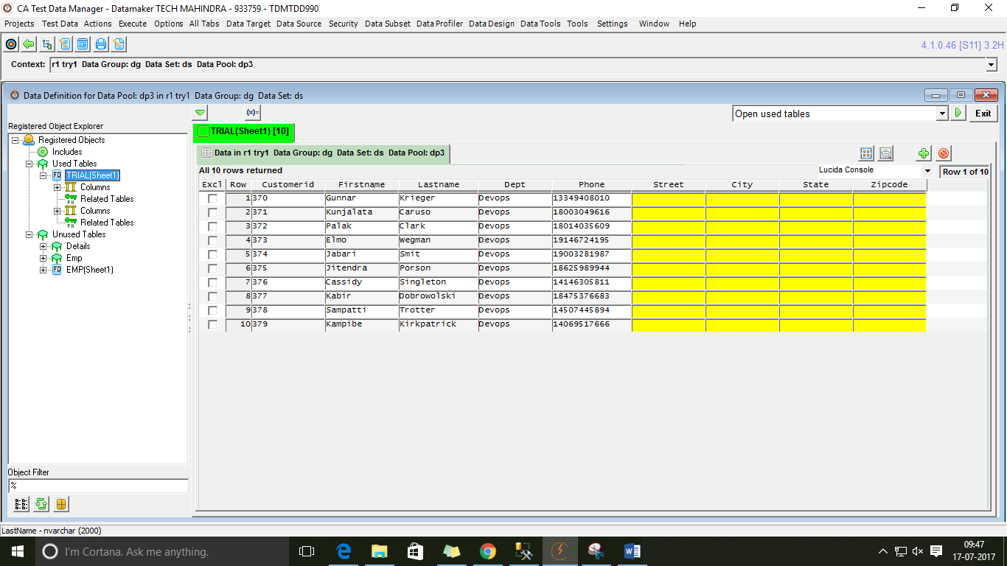

1. Functions > Select **@randlov(percnull,@seedlist(seedname)@,seedcolumn)@**

In Select Required seed list > Address ( Created seed table name)



1. Mention below values and validate

Percnull: 0

Seedcolumn:1



1. Repeat the process as above by changing the seed column values as follows for:

City: @randlov(0,@seedlist(Address)@,2)@

State: @randlov(0,@seedlist(Address)@,3)@

Zipcode: @randlov(0,@seedlist(Address)@,4)@

1. Copy same generation rule for all the rows. Select Publish to file from drop down.

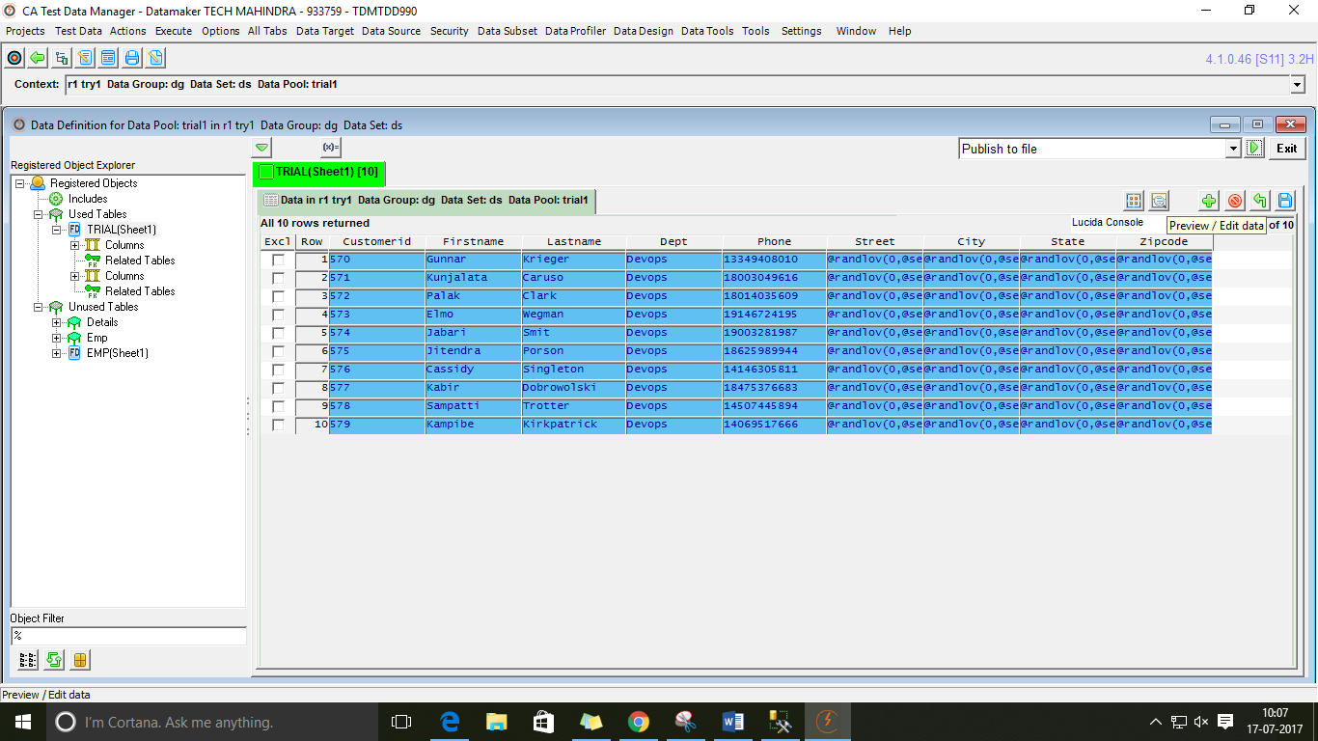

1. Select Publish to excel file and run.

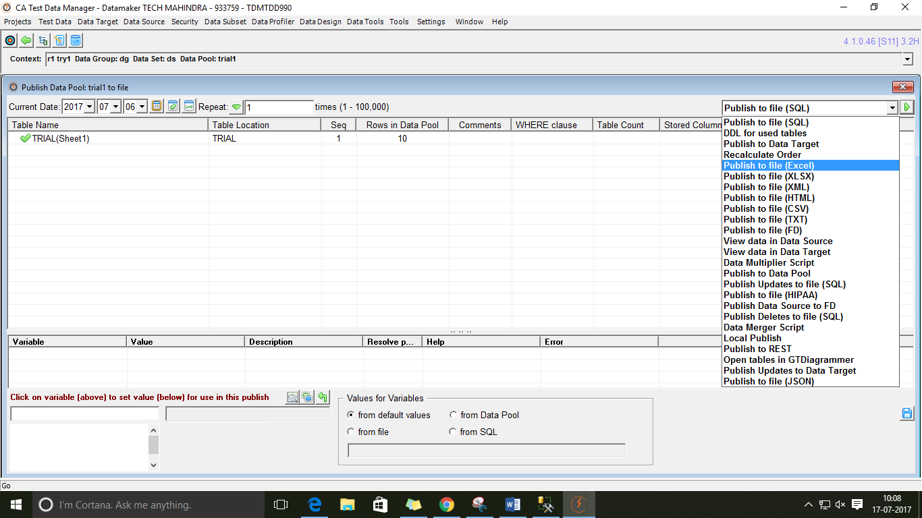

1. Click on run.

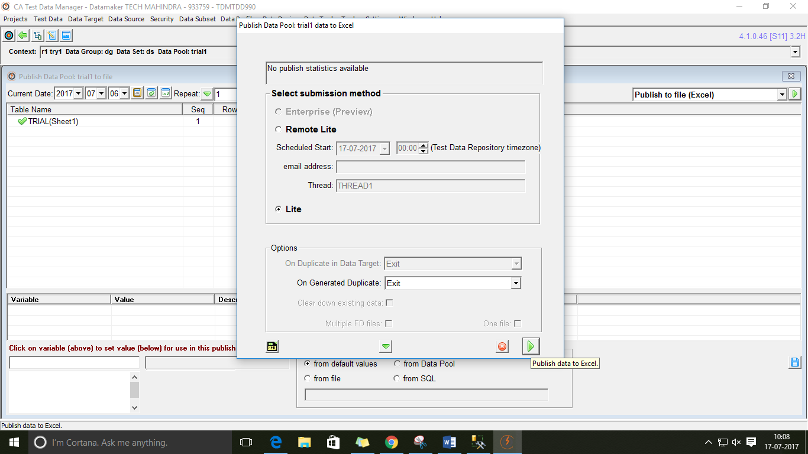

1. Browse to required location to store the excel file.

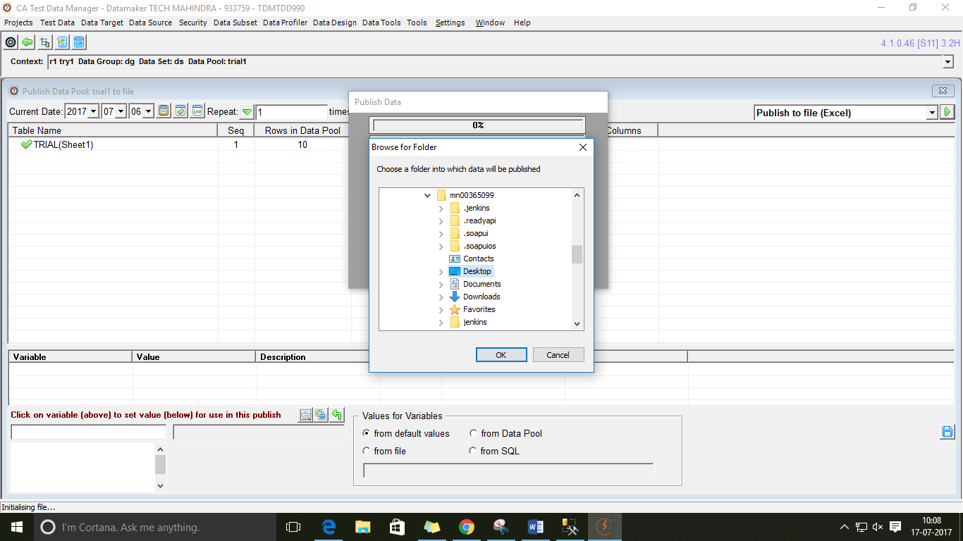

1. Data is published to the excel file. Click ok.

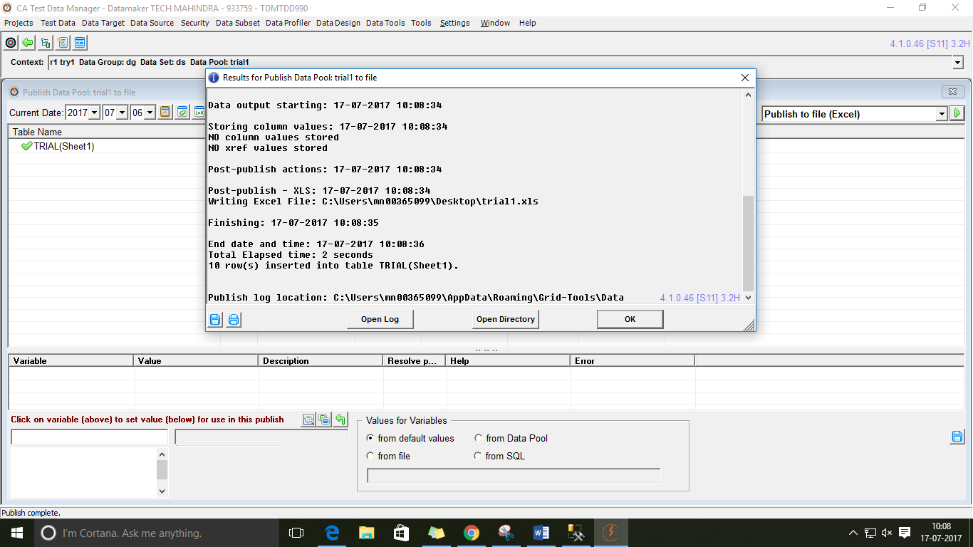

Excel file used:

